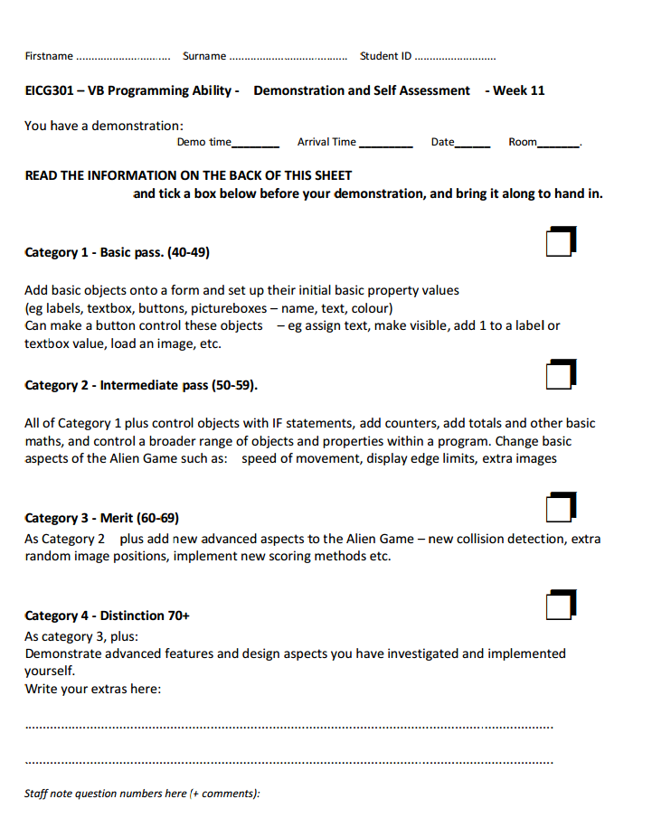

ALien Invader Game

EICG301.Y : Introduction to Programing and Games Design

Kristen Hayzelden

W1508466

Design View

# Menu

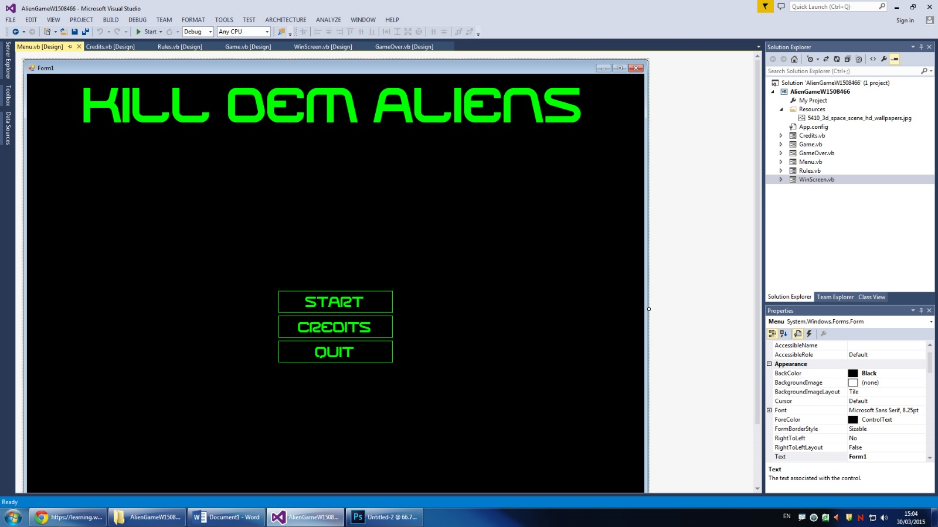

# CreditsH:\Introduction to Programming and Games Design Project\Alien Game\screenshots\designcredits.jpg

# Rules

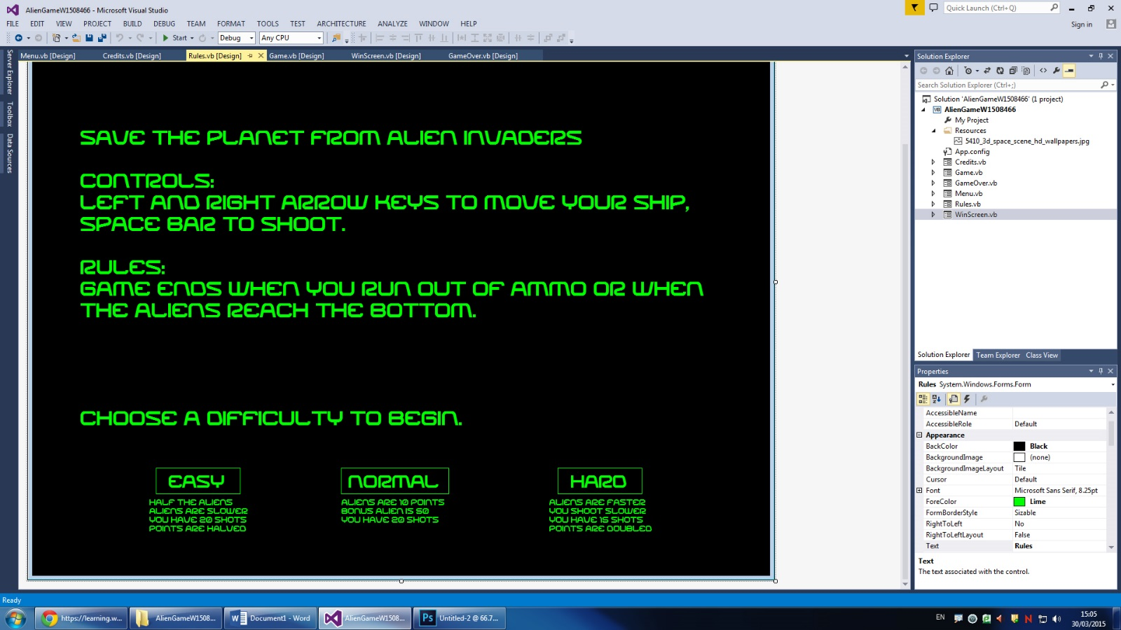

# Game

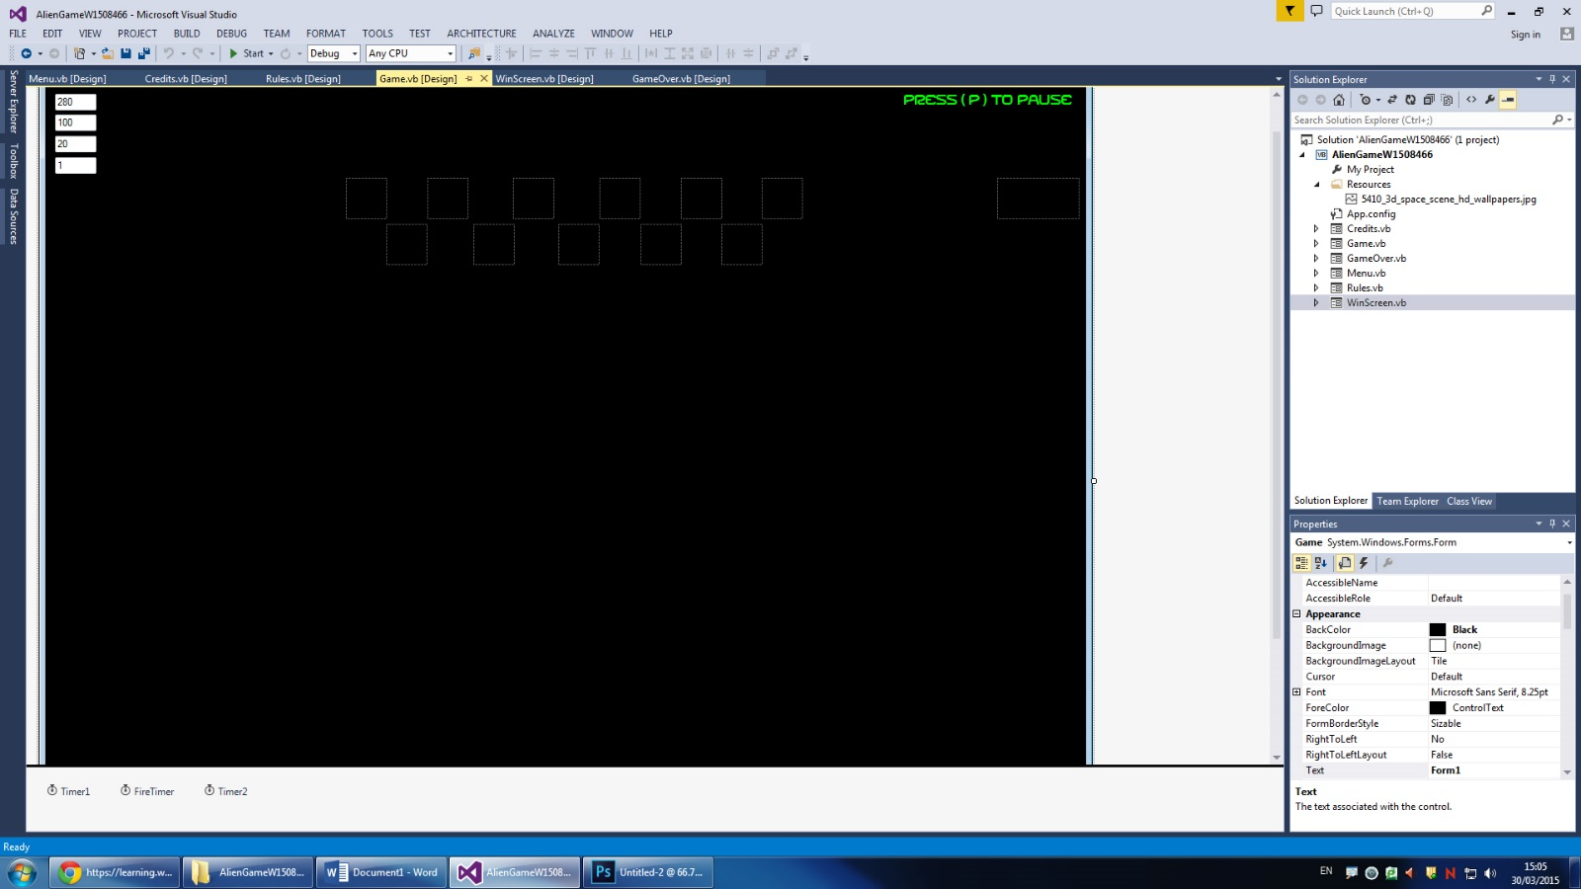

*note the gun is below the cut off, as well as 20 ammo image boxes and a label saying “ammo”

# Game Over

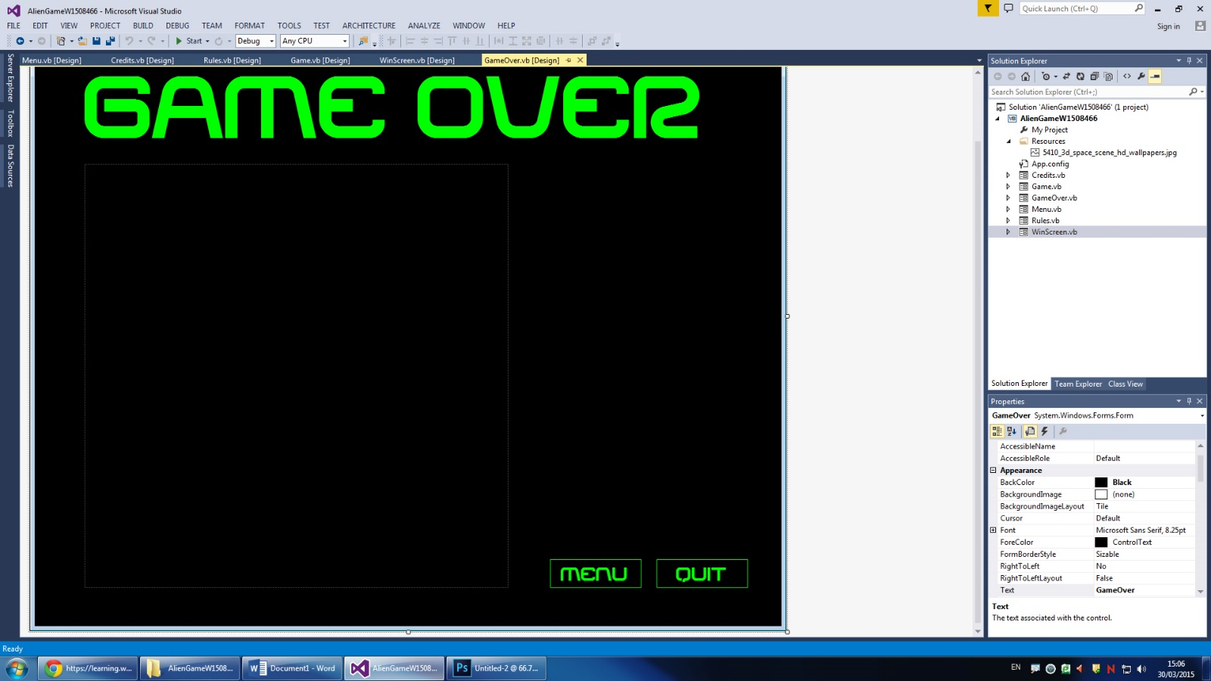

# Win Screen

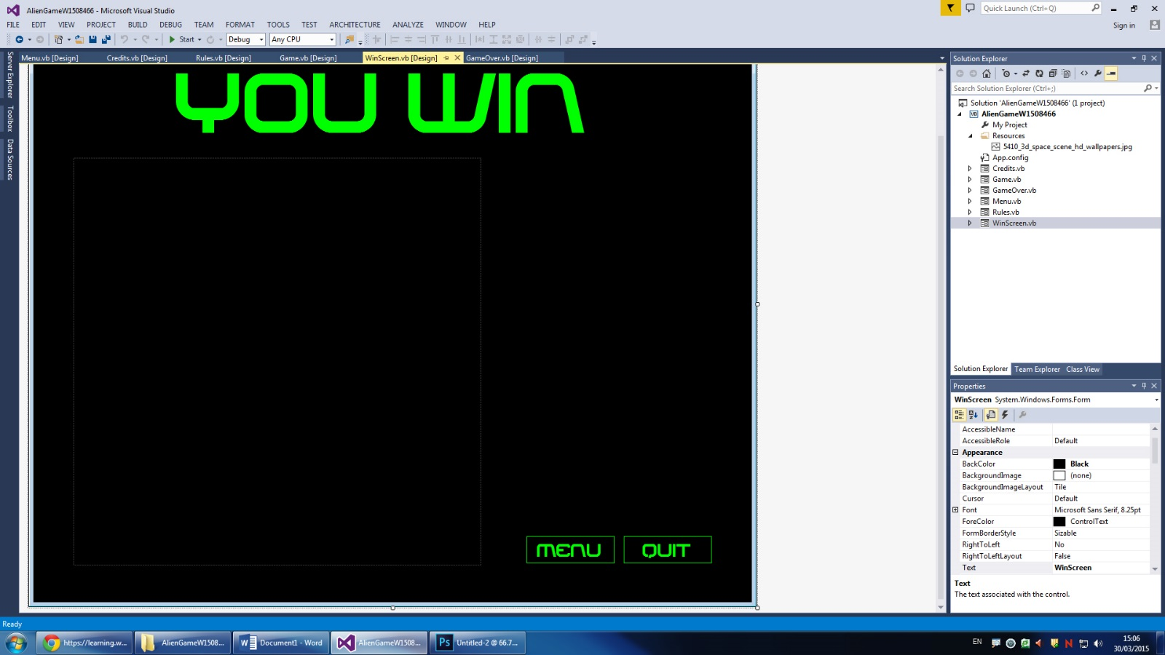

Run Time View

# MenuH:\Introduction to Programming and Games Design Project\Alien Game\screenshots\runmenu.jpg

The Menu has three options. Start leads to the Rules screen, Credits leads to the credits page with links from my sources, and quit terminated the application.

# Credits

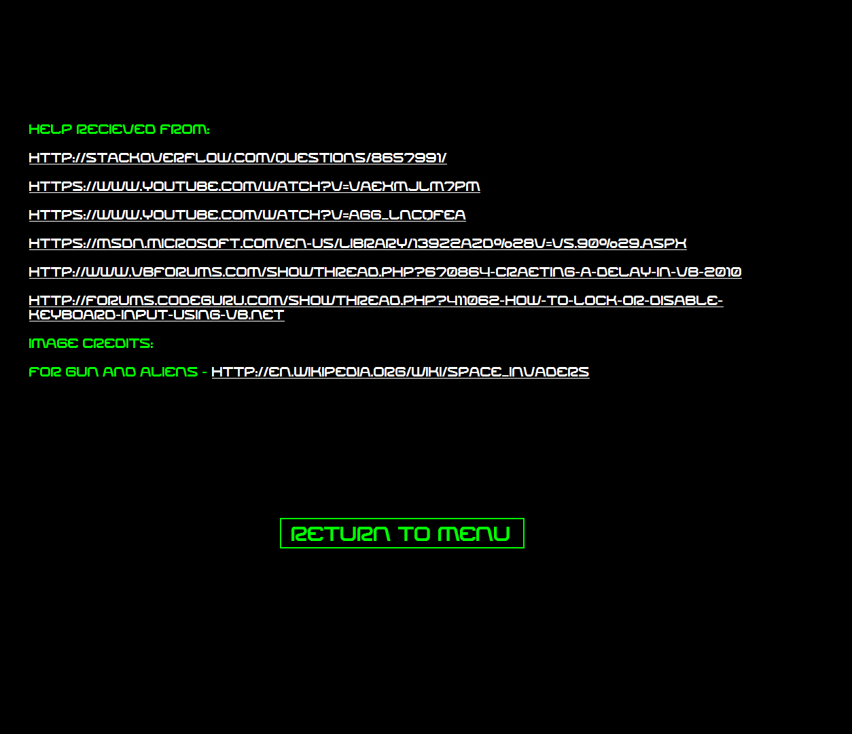

The credits page has links to the sources I used for help and image credits. The button at the bottom returns to the menu screen.

# Rules

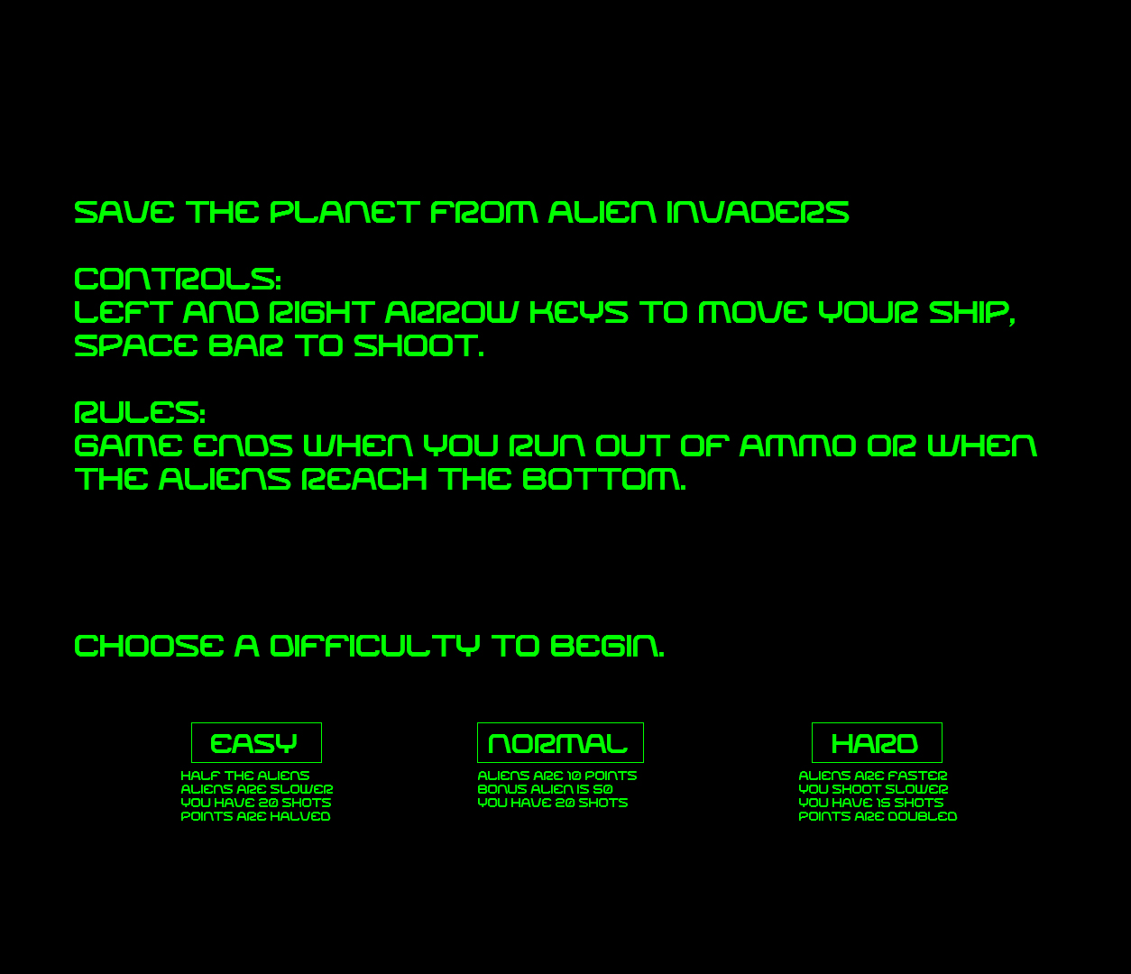

The rules page explains the mechanics of the game and lets you pick a difficulty (the changes therefore are explained below). Each button leads to the game form but changes certain things such as timer speeds and ammo limits.

# Game

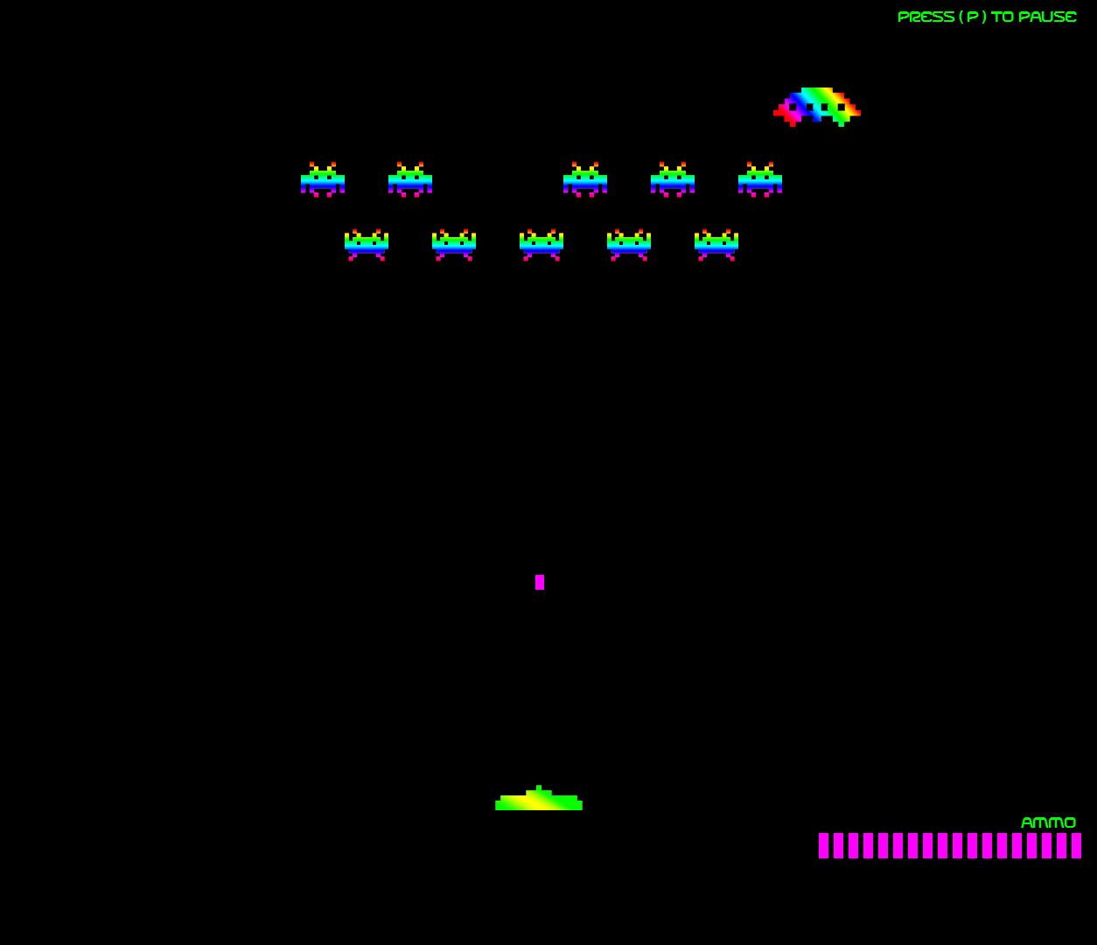

This shot shows the game on normal difficulty. On hard there is less ammo and on easy there are less aliens (only top row). In this screenshot I have already shot one alien (the 3rd one) and am mid fire. One “ammo” picture has disappeared with my first shot, and another will go when the current bullet hits the top of the screen or an alien. The large alien at the top is the bonus alien that happens every 40 ticks of the timer and is worth more (it moves from right to left once then disappears)

# Game Paused

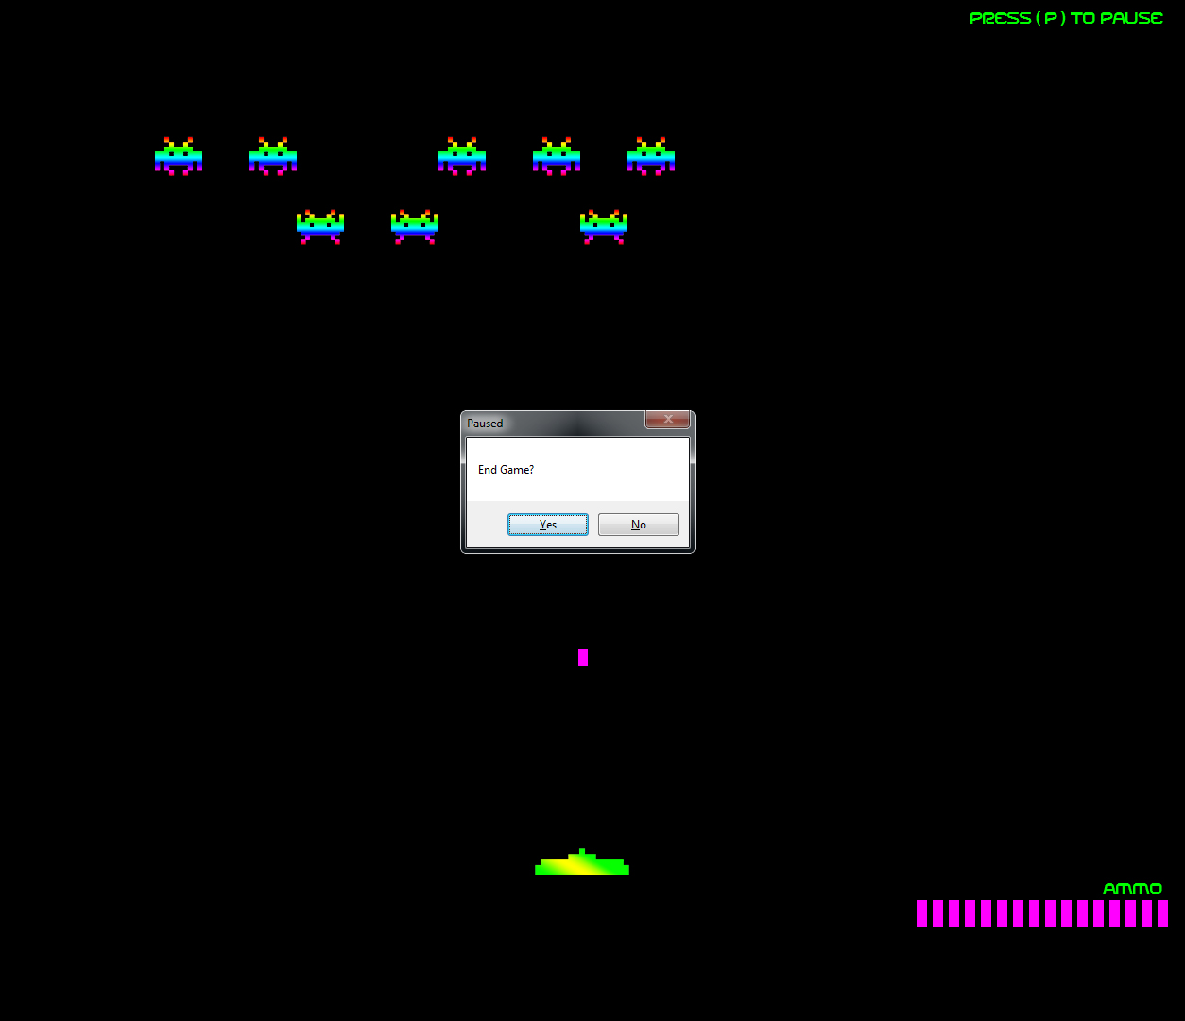

This is the screen after the “p” key is pressed mid game. The aliens and bullet freeze and the user is prompted to end game or not. If they click no then the timers resume and the game goes back to exactly when paused, if they click yes it leads to the game over screen.

# Game OverH:\Introduction to Programming and Games Design Project\Alien Game\screenshots\rungameoverscreen.jpg

This is the game over screen, the score depends on the user and is updated each time. The menu button returns to the menu, allowing the user to play again if they wish, and the quit button exits the application.

# Win Screen

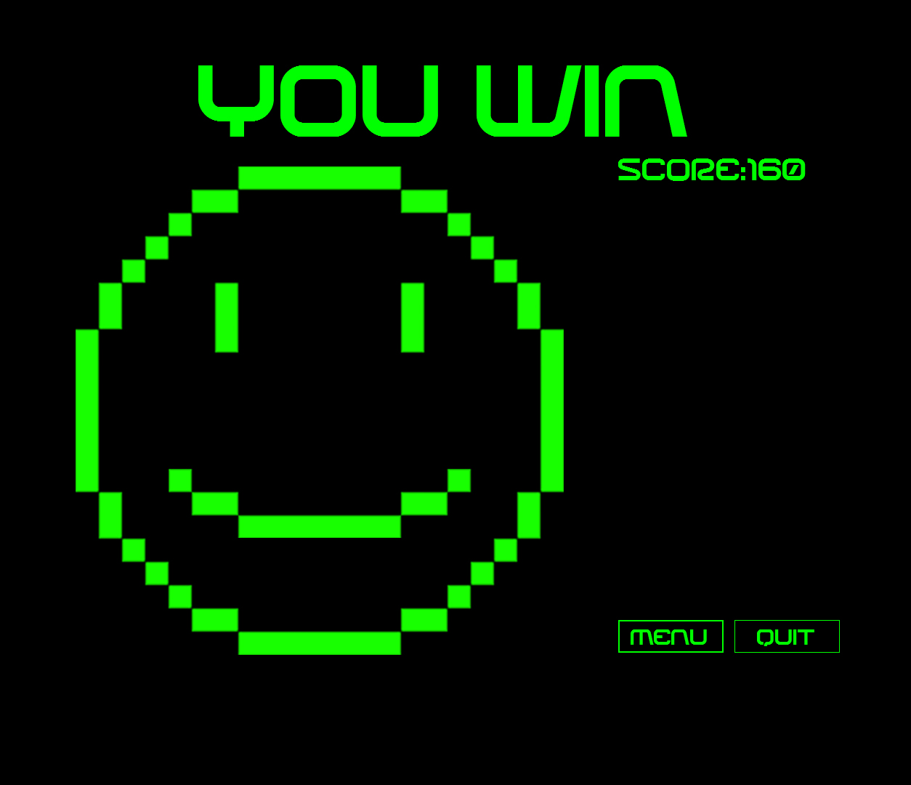

This is the winning screen, the score depends on the user and is updated each time. The menu button returns to the menu, allowing the user to play again if they wish, and the quit button exits the application.

Code

Public Class Menu

Private Sub Menu_Load(sender As Object, e As EventArgs) Handles MyBase.Load

Me.FormBorderStyle = Windows.Forms.FormBorderStyle.None

Me.WindowState = FormWindowState.Maximized

End Sub

Private Sub StartGame_Click(sender As Object, e As EventArgs) Handles StartGame.Click

Dim Rules As New Rules

Rules.Show()

Me.Hide()

End Sub

Private Sub Button2_Click(sender As Object, e As EventArgs) Handles Button2.Click

Application.Exit()

End Sub

Private Sub Credits_Click(sender As Object, e As EventArgs) Handles Credits.Click

Dim Credits As New Credits

Credits.Show()

Me.Hide()

End Sub

End Class

Public Class Credits

Private Sub Credits_Load(sender As Object, e As EventArgs) Handles MyBase.Load

Me.FormBorderStyle = Windows.Forms.FormBorderStyle.None

Me.WindowState = FormWindowState.Maximized

End Sub

Private Sub Buton1_Click(sender As Object, e As EventArgs) Handles Buton1.Click

Dim Menu As New Menu

Menu.Show()

Me.Close()

End Sub

End Class

Public Class Rules

Public Declare Function apiBlockInput Lib "user32" Alias "BlockInput" (ByVal fBlock As Integer) As Integer

Private Sub Rules_Load(sender As Object, e As EventArgs) Handles MyBase.Load

Me.FormBorderStyle = Windows.Forms.FormBorderStyle.None

Me.WindowState = FormWindowState.Maximized

End Sub

Private Sub Easy_Click(sender As Object, e As EventArgs) Handles Easy.Click

Game.difficulty.Text = 0

Game.Show()

Me.Hide()

End Sub

Private Sub Normal_Click(sender As Object, e As EventArgs) Handles Normal.Click

Game.difficulty.Text = 1

Game.Show()

Me.Hide()

End Sub

Private Sub Hard_Click(sender As Object, e As EventArgs) Handles Hard.Click

Game.difficulty.Text = 2

Game.Show()

Me.Hide()

End Sub

End Class

Public Class Game

Dim NumShots As Integer

Dim Points As Integer

Dim RandomAlien As Integer

Public Declare Function apiBlockInput Lib "user32" Alias "BlockInput" (ByVal fBlock As Integer) As Integer

Private Sub Timer1_Tick(sender As Object, e As EventArgs) Handles Timer1.Tick

Alien1.Location = New Point(Xpos.Text, Ypos.Text)

Alien2.Location = New Point(Xpos.Text + 100, Ypos.Text)

Alien3.Location = New Point(Xpos.Text + 200, Ypos.Text)

Alien4.Location = New Point(Xpos.Text + 300, Ypos.Text)

Alien5.Location = New Point(Xpos.Text + 400, Ypos.Text)

Alien6.Location = New Point(Xpos.Text + 500, Ypos.Text)

Alien7.Location = New Point(Xpos.Text + 50, Ypos.Text + 75)

Alien8.Location = New Point(Xpos.Text + 150, Ypos.Text + 75)

Alien9.Location = New Point(Xpos.Text + 250, Ypos.Text + 75)

Alien10.Location = New Point(Xpos.Text + 350, Ypos.Text + 75)

Alien11.Location = New Point(Xpos.Text + 450, Ypos.Text + 75)

If (Xpos.Text Mod 80 = 0) Then

Alien1.Image = Image.FromFile("H:\Introduction to Programming and Games Design Project\Alien Game\alienup.png")

Alien2.Image = Image.FromFile("H:\Introduction to Programming and Games Design Project\Alien Game\alienup.png")

Alien3.Image = Image.FromFile("H:\Introduction to Programming and Games Design Project\Alien Game\alienup.png")

Alien4.Image = Image.FromFile("H:\Introduction to Programming and Games Design Project\Alien Game\alienup.png")

Alien5.Image = Image.FromFile("H:\Introduction to Programming and Games Design Project\Alien Game\alienup.png")

Alien6.Image = Image.FromFile("H:\Introduction to Programming and Games Design Project\Alien Game\alienup.png")

Alien7.Image = Image.FromFile("H:\Introduction to Programming and Games Design Project\Alien Game\aliendown.png")

Alien8.Image = Image.FromFile("H:\Introduction to Programming and Games Design Project\Alien Game\aliendown.png")

Alien9.Image = Image.FromFile("H:\Introduction to Programming and Games Design Project\Alien Game\aliendown.png")

Alien10.Image = Image.FromFile("H:\Introduction to Programming and Games Design Project\Alien Game\aliendown.png")

Alien11.Image = Image.FromFile("H:\Introduction to Programming and Games Design Project\Alien Game\aliendown.png")

Else

Alien1.Image = Image.FromFile("H:\Introduction to Programming and Games Design Project\Alien Game\aliendown.png")

Alien2.Image = Image.FromFile("H:\Introduction to Programming and Games Design Project\Alien Game\aliendown.png")

Alien3.Image = Image.FromFile("H:\Introduction to Programming and Games Design Project\Alien Game\aliendown.png")

Alien4.Image = Image.FromFile("H:\Introduction to Programming and Games Design Project\Alien Game\aliendown.png")

Alien5.Image = Image.FromFile("H:\Introduction to Programming and Games Design Project\Alien Game\aliendown.png")

Alien6.Image = Image.FromFile("H:\Introduction to Programming and Games Design Project\Alien Game\aliendown.png")

Alien7.Image = Image.FromFile("H:\Introduction to Programming and Games Design Project\Alien Game\alienup.png")

Alien8.Image = Image.FromFile("H:\Introduction to Programming and Games Design Project\Alien Game\alienup.png")

Alien9.Image = Image.FromFile("H:\Introduction to Programming and Games Design Project\Alien Game\alienup.png")

Alien10.Image = Image.FromFile("H:\Introduction to Programming and Games Design Project\Alien Game\alienup.png")

Alien11.Image = Image.FromFile("H:\Introduction to Programming and Games Design Project\Alien Game\alienup.png")

End If

Xpos.Text += Int(RightAdd.Text)

'screen resloution 1280 (x) x 1024 (y)

If (Xpos.Text + 550 > 1100) Then

RightAdd.Text = -20

Ypos.Text += 40

End If

If (Xpos.Text < 180) Then

RightAdd.Text = 20

Ypos.Text += 40

End If

If (Ypos.Text + 150 > Gun.Location.Y + 50) Then

Timer1.Enabled = False

apiBlockInput(1)

System.Threading.Thread.Sleep(500)

Dim GameOver As New GameOver

GameOver.points.Text = ("Score:" & Points)

GameOver.Show()

Me.Close()

End If

If (FireTimer.Enabled = False And NumShots = 20 And (Alien1.Visible = True Or Alien2.Visible = True Or Alien3.Visible = True Or Alien4.Visible = True Or Alien5.Visible = True Or Alien6.Visible = True Or Alien7.Visible = True Or Alien8.Visible = True Or Alien9.Visible = True Or Alien10.Visible = True Or Alien11.Visible = True)) Then

Timer1.Enabled = False

apiBlockInput(1)

System.Threading.Thread.Sleep(500)

Dim GameOver As New GameOver

GameOver.points.Text = ("Score:" & Points)

GameOver.Show()

Me.Close()

End If

If (NumShots > 0 And Alien1.Visible = False And Alien2.Visible = False And Alien3.Visible = False And Alien4.Visible = False And Alien5.Visible = False And Alien6.Visible = False And Alien7.Visible = False And Alien8.Visible = False And Alien9.Visible = False And Alien10.Visible = False And Alien11.Visible = False) Then

Timer1.Enabled = False

apiBlockInput(1)

System.Threading.Thread.Sleep(500)

Dim WinScreen As New WinScreen

WinScreen.points.Text = ("Score:" & Points)

WinScreen.Show()

Me.Close()

End If

RandomAlien += 1

If (RandomAlien Mod 40 = 0) Then

Timer2.Enabled = True

End If

End Sub

Private Sub Form1_KeyDown(sender As Object, e As KeyEventArgs) Handles Me.KeyDown

If (e.KeyCode = Keys.Right And Gun.Location.X < 1200) Then

Gun.Location = New Point(Gun.Location.X + 10, Gun.Location.Y)

If (Bullet.Location.Y = Gun.Location.Y) Then

Bullet.Location = New Point(Bullet.Location.X + 10, Bullet.Location.Y)

End If

End If

If (e.KeyCode = Keys.Left And Gun.Location.X > 25) Then

Gun.Location = New Point(Gun.Location.X - 10, Gun.Location.Y)

If (Bullet.Location.Y = Gun.Location.Y) Then

Bullet.Location = New Point(Bullet.Location.X - 10, Bullet.Location.Y)

End If

End If

If (e.KeyCode = Keys.Space And FireTimer.Enabled = False And NumShots < 20) Then

FireTimer.Enabled = True

NumShots += 1

If (NumShots = 1) Then

ammo1.Visible = False

ElseIf (NumShots = 2) Then

ammo2.Visible = False

ElseIf (NumShots = 3) Then

ammo3.Visible = False

ElseIf (NumShots = 4) Then

ammo4.Visible = False

ElseIf (NumShots = 5) Then

ammo5.Visible = False

ElseIf (NumShots = 6) Then

ammo6.Visible = False

ElseIf (NumShots = 7) Then

ammo7.Visible = False

ElseIf (NumShots = 8) Then

ammo8.Visible = False

ElseIf (NumShots = 9) Then

ammo9.Visible = False

ElseIf (NumShots = 10) Then

ammo10.Visible = False

ElseIf (NumShots = 11) Then

ammo11.Visible = False

ElseIf (NumShots = 12) Then

ammo12.Visible = False

ElseIf (NumShots = 13) Then

ammo13.Visible = False

ElseIf (NumShots = 14) Then

ammo14.Visible = False

ElseIf (NumShots = 15) Then

ammo15.Visible = False

ElseIf (NumShots = 16) Then

ammo16.Visible = False

ElseIf (NumShots = 17) Then

ammo17.Visible = False

ElseIf (NumShots = 18) Then

ammo18.Visible = False

ElseIf (NumShots = 19) Then

ammo19.Visible = False

ElseIf (NumShots = 20) Then

ammo20.Visible = False

End If

End If

If (e.KeyCode = Keys.P) Then

Dim resettimer As Boolean = False

Dim resettimer2 As Boolean = False

If (Timer2.Enabled = True) Then

resettimer2 = True

End If

If (FireTimer.Enabled = True) Then

resettimer = True

End If

Timer1.Enabled = False

Timer2.Enabled = False

FireTimer.Enabled = False

Dim ReturnToMenu = MsgBox("End Game?", MsgBoxStyle.YesNo, "Paused")

If (ReturnToMenu = 6) Then

Timer1.Enabled = False

Dim GameOver As New GameOver

GameOver.points.Text = ("Score:" & Points)

GameOver.Show()

Me.Close()

Else

Timer1.Enabled = True

If (resettimer = True) Then

FireTimer.Enabled = True

End If

If (resettimer2 = True) Then

Timer2.Enabled = True

End If

End If

End If

End Sub

Private Sub FireTimer_Tick(sender As Object, e As EventArgs) Handles FireTimer.Tick

Bullet.Location = New Point(Bullet.Location.X, Bullet.Location.Y - 15)

If (Bullet.Bounds.IntersectsWith(Alien1.Bounds) And Alien1.Visible = True) Then

My.Computer.Audio.PlaySystemSound(Media.SystemSounds.Beep)

FireTimer.Enabled = False

Bullet.Visible = False

Alien1.Visible = False

If (NumShots < 20) Then

Bullet.Location = New Point(Gun.Location.X + 46, Gun.Location.Y)

Bullet.Visible = True

End If

If (difficulty.Text = 0) Then

Points += 5

ElseIf (difficulty.Text = 1) Then

Points += 10

ElseIf (difficulty.Text = 2) Then

Points += 20

End If

End If

If (Bullet.Bounds.IntersectsWith(Alien2.Bounds) And Alien2.Visible = True) Then

My.Computer.Audio.PlaySystemSound(Media.SystemSounds.Beep)

FireTimer.Enabled = False

Bullet.Visible = False

Alien2.Visible = False

If (NumShots < 20) Then

Bullet.Location = New Point(Gun.Location.X + 46, Gun.Location.Y)

Bullet.Visible = True

End If

If (difficulty.Text = 0) Then

Points += 5

ElseIf (difficulty.Text = 1) Then

Points += 10

ElseIf (difficulty.Text = 2) Then

Points += 20

End If

End If

If (Bullet.Bounds.IntersectsWith(Alien3.Bounds) And Alien3.Visible = True) Then

My.Computer.Audio.PlaySystemSound(Media.SystemSounds.Beep)

FireTimer.Enabled = False

Bullet.Visible = False

Alien3.Visible = False

If (NumShots < 20) Then

Bullet.Location = New Point(Gun.Location.X + 46, Gun.Location.Y)

Bullet.Visible = True

End If

If (difficulty.Text = 0) Then

Points += 5

ElseIf (difficulty.Text = 1) Then

Points += 10

ElseIf (difficulty.Text = 2) Then

Points += 20

End If

End If

If (Bullet.Bounds.IntersectsWith(Alien4.Bounds) And Alien4.Visible = True) Then

My.Computer.Audio.PlaySystemSound(Media.SystemSounds.Beep)

FireTimer.Enabled = False

Bullet.Visible = False

Alien4.Visible = False

If (NumShots < 20) Then

Bullet.Location = New Point(Gun.Location.X + 46, Gun.Location.Y)

Bullet.Visible = True

End If

If (difficulty.Text = 0) Then

Points += 5

ElseIf (difficulty.Text = 1) Then

Points += 10

ElseIf (difficulty.Text = 2) Then

Points += 20

End If

End If

If (Bullet.Bounds.IntersectsWith(Alien5.Bounds) And Alien5.Visible = True) Then

My.Computer.Audio.PlaySystemSound(Media.SystemSounds.Beep)

FireTimer.Enabled = False

Bullet.Visible = False

Alien5.Visible = False

If (NumShots < 20) Then

Bullet.Location = New Point(Gun.Location.X + 46, Gun.Location.Y)

Bullet.Visible = True

End If

If (difficulty.Text = 0) Then

Points += 5

ElseIf (difficulty.Text = 1) Then

Points += 10

ElseIf (difficulty.Text = 2) Then

Points += 20

End If

End If

If (Bullet.Bounds.IntersectsWith(Alien6.Bounds) And Alien6.Visible = True) Then

My.Computer.Audio.PlaySystemSound(Media.SystemSounds.Beep)

FireTimer.Enabled = False

Bullet.Visible = False

Alien6.Visible = False

If (NumShots < 20) Then

Bullet.Location = New Point(Gun.Location.X + 46, Gun.Location.Y)

Bullet.Visible = True

End If

If (difficulty.Text = 0) Then

Points += 5

ElseIf (difficulty.Text = 1) Then

Points += 10

ElseIf (difficulty.Text = 2) Then

Points += 20

End If

End If

If (Bullet.Bounds.IntersectsWith(Alien7.Bounds) And Alien7.Visible = True) Then

My.Computer.Audio.PlaySystemSound(Media.SystemSounds.Beep)

FireTimer.Enabled = False

Bullet.Visible = False

Alien7.Visible = False

If (NumShots < 20) Then

Bullet.Location = New Point(Gun.Location.X + 46, Gun.Location.Y)

Bullet.Visible = True

End If

If (difficulty.Text = 0) Then

Points += 5

ElseIf (difficulty.Text = 1) Then

Points += 10

ElseIf (difficulty.Text = 2) Then

Points += 20

End If

End If

If (Bullet.Bounds.IntersectsWith(Alien8.Bounds) And Alien8.Visible = True) Then

My.Computer.Audio.PlaySystemSound(Media.SystemSounds.Beep)

FireTimer.Enabled = False

Bullet.Visible = False

Alien8.Visible = False

If (NumShots < 20) Then

Bullet.Location = New Point(Gun.Location.X + 46, Gun.Location.Y)

Bullet.Visible = True

End If

If (difficulty.Text = 0) Then

Points += 5

ElseIf (difficulty.Text = 1) Then

Points += 10

ElseIf (difficulty.Text = 2) Then

Points += 20

End If

End If

If (Bullet.Bounds.IntersectsWith(Alien9.Bounds) And Alien9.Visible = True) Then

My.Computer.Audio.PlaySystemSound(Media.SystemSounds.Beep)

FireTimer.Enabled = False

Bullet.Visible = False

Alien9.Visible = False

If (NumShots < 20) Then

Bullet.Location = New Point(Gun.Location.X + 46, Gun.Location.Y)

Bullet.Visible = True

End If

If (difficulty.Text = 0) Then

Points += 5

ElseIf (difficulty.Text = 1) Then

Points += 10

ElseIf (difficulty.Text = 2) Then

Points += 20

End If

End If

If (Bullet.Bounds.IntersectsWith(Alien10.Bounds) And Alien10.Visible = True) Then

My.Computer.Audio.PlaySystemSound(Media.SystemSounds.Beep)

FireTimer.Enabled = False

Bullet.Visible = False

Alien10.Visible = False

If (NumShots < 20) Then

Bullet.Location = New Point(Gun.Location.X + 46, Gun.Location.Y)

Bullet.Visible = True

End If

If (difficulty.Text = 0) Then

Points += 5

ElseIf (difficulty.Text = 1) Then

Points += 10

ElseIf (difficulty.Text = 2) Then

Points += 20

End If

End If

If (Bullet.Bounds.IntersectsWith(Alien11.Bounds) And Alien11.Visible = True) Then

My.Computer.Audio.PlaySystemSound(Media.SystemSounds.Beep)

FireTimer.Enabled = False

Bullet.Visible = False

Alien11.Visible = False

If (NumShots < 20) Then

Bullet.Location = New Point(Gun.Location.X + 46, Gun.Location.Y)

Bullet.Visible = True

End If

If (difficulty.Text = 0) Then

Points += 5

ElseIf (difficulty.Text = 1) Then

Points += 10

ElseIf (difficulty.Text = 2) Then

Points += 20

End If

End If

If (Bullet.Bounds.IntersectsWith(Alien12.Bounds) And Alien12.Visible = True) Then

My.Computer.Audio.PlaySystemSound(Media.SystemSounds.Beep)

FireTimer.Enabled = False

Timer2.Enabled = False

Bullet.Visible = False

Alien12.Visible = False

Alien12.Location = New Point(1300, 100)

If (NumShots < 20) Then

Bullet.Location = New Point(Gun.Location.X + 46, Gun.Location.Y)

Bullet.Visible = True

End If

If (difficulty.Text = 0) Then

Points += 25

ElseIf (difficulty.Text = 1) Then

Points += 50

ElseIf (difficulty.Text = 2) Then

Points += 100

End If

End If

If (Bullet.Location.Y < 100) Then

FireTimer.Enabled = False

Bullet.Visible = False

If (NumShots < 20) Then

Bullet.Location = New Point(Gun.Location.X + 46, Gun.Location.Y)

Bullet.Visible = True

End If

End If

End Sub

Private Sub Game_Load(sender As Object, e As EventArgs) Handles Me.Load

Me.FormBorderStyle = Windows.Forms.FormBorderStyle.None

Me.WindowState = FormWindowState.Maximized

apiBlockInput(0)

'Me.KeyPreview = True

Alien12.Location = New Point(1300, 100)

Gun.Image = Image.FromFile("H:\Introduction to Programming and Games Design Project\Alien Game\gun.png")

If (difficulty.Text = 0) Then

Alien7.Visible = False

Alien8.Visible = False

Alien9.Visible = False

Alien10.Visible = False

Alien11.Visible = False

Timer1.Interval = Timer1.Interval + 100

Timer2.Interval = Timer2.Interval + 50

End If

If (difficulty.Text = 2) Then

Timer1.Interval = Timer1.Interval - 150

Timer2.Interval = Timer2.Interval - 50

NumShots = 5

ammo1.Visible = False

ammo2.Visible = False

ammo3.Visible = False

ammo4.Visible = False

ammo5.Visible = False

End If

End Sub

Private Sub Timer2_Tick(sender As Object, e As EventArgs) Handles Timer2.Tick

Alien12.Image = Image.FromFile("H:\Introduction to Programming and Games Design Project\Alien Game\special alien.png")

Alien12.Visible = True

If (Alien12.Location.X > 0) Then

Alien12.Location = New Point(Alien12.Location.X - 40, Alien12.Location.Y)

Else

Timer2.Enabled = False

Alien12.Visible = False

Alien12.Location = New Point(1300, 100)

End If

End Sub

End Class

Public Class GameOver

Public Declare Function apiBlockInput Lib "user32" Alias "BlockInput" (ByVal fBlock As Integer) As Integer

Private Sub GameOver_Load(sender As Object, e As EventArgs) Handles MyBase.Load

apiBlockInput(1)

Me.FormBorderStyle = Windows.Forms.FormBorderStyle.None

Me.WindowState = FormWindowState.Maximized

frown.Image = Image.FromFile("H:\Introduction to Programming and Games Design Project\Alien Game\lose.png")

End Sub

Private Sub Quit_Click_1(sender As Object, e As EventArgs) Handles Quit.Click

Application.Exit()

End Sub

Private Sub menu_Click(sender As Object, e As EventArgs) Handles menu.Click

Dim Menu As New Menu

Menu.Show()

Me.Close()

End Sub

End Class

Public Class WinScreen

Private Sub WinScreen_Load(sender As Object, e As EventArgs) Handles MyBase.Load

Me.FormBorderStyle = Windows.Forms.FormBorderStyle.None

Me.WindowState = FormWindowState.Maximized

smile.Image = Image.FromFile("H:\Introduction to Programming and Games Design Project\Alien Game\win.png")

End Sub

Private Sub menu_Click_1(sender As Object, e As EventArgs) Handles menu.Click

Dim Menu As New Menu

Menu.Show()

Me.Close()

End Sub

Private Sub Quit_Click_1(sender As Object, e As EventArgs) Handles Quit.Click

Application.Exit()

End Sub

End Class